

The Surpora Thomas Pediatric
Nursing Education and Research Center

PRECEPTORSHIP ORIENTATION

CERTIFICATE OF COMPLETION

Date: July 30, 2026

Signature: ________________________

My signature verifies that I have read and completed
the on-line orientation materials for
my preceptorship nursing course
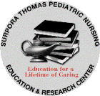
on the above date.

